Data Analytics (DA)
Module-End -1
Module End Assignment:
“Data Cleaning, Analysis & Visualization with Excel”
Name: Seric Sunil
Batch: 69

Steps taken for this work
- Loaded the data from link source.
- Cleaned the entire Data. Used tools like Find and replace, Flash fills etc. Tried to figure out duplicates but can’t recognise any. Many customer names have been repetitive but rest of the factors like age, gender. Region, ID varies.

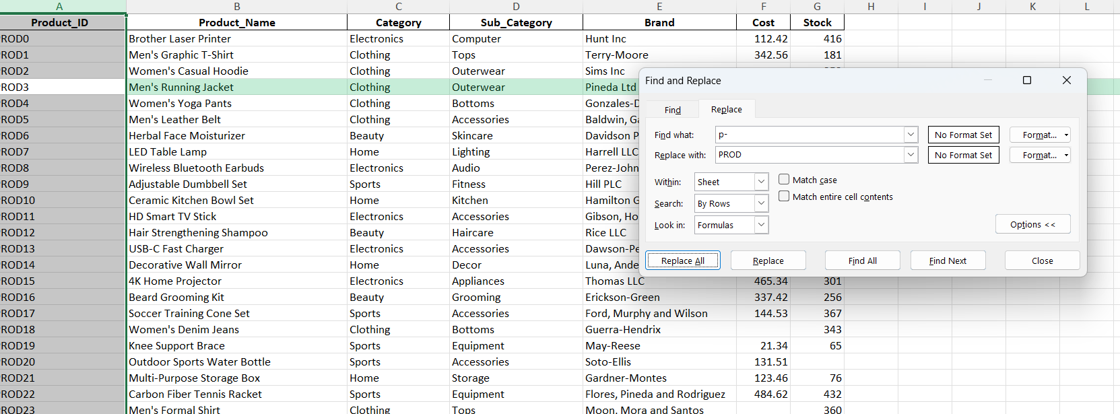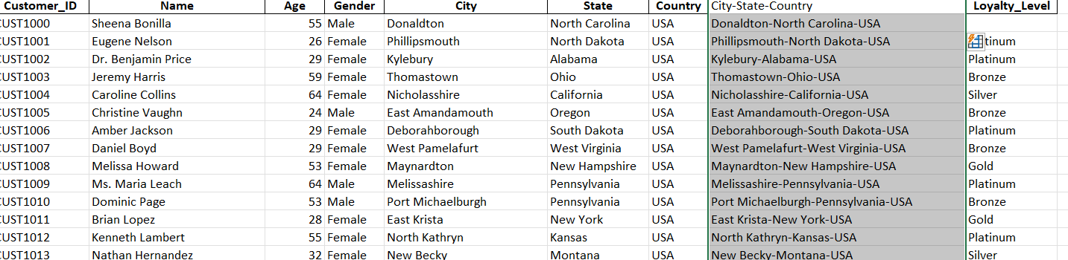
- Used lookup function (Xlookups) to combine the data to form a table format.
Data from all four sheets were combined to one using xlookup function in this way. $ signs were added to the range to prevent the errors.
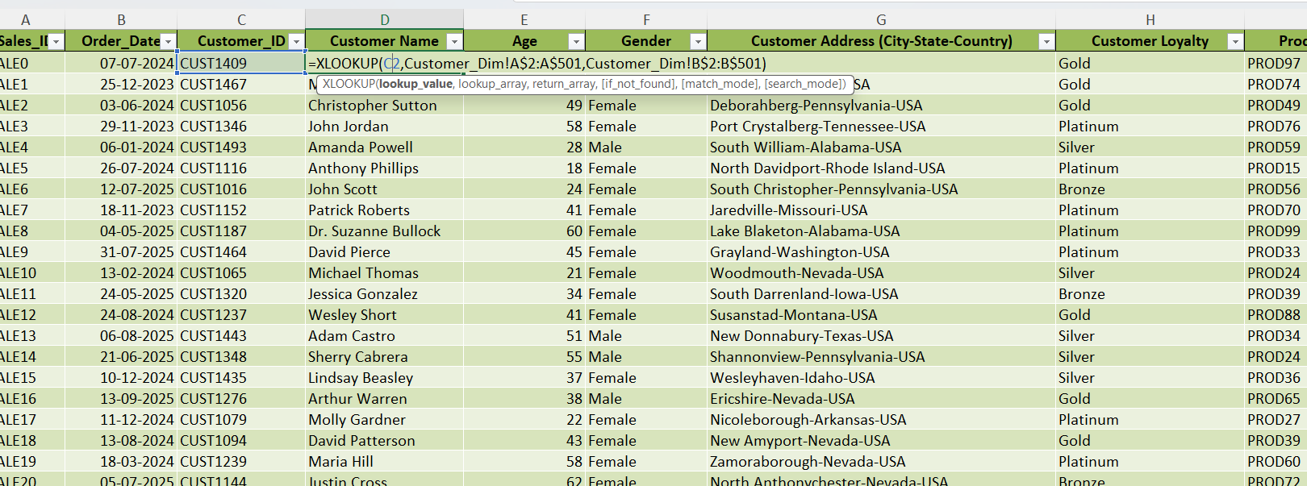

- We changed the order date, currency and also discount format.
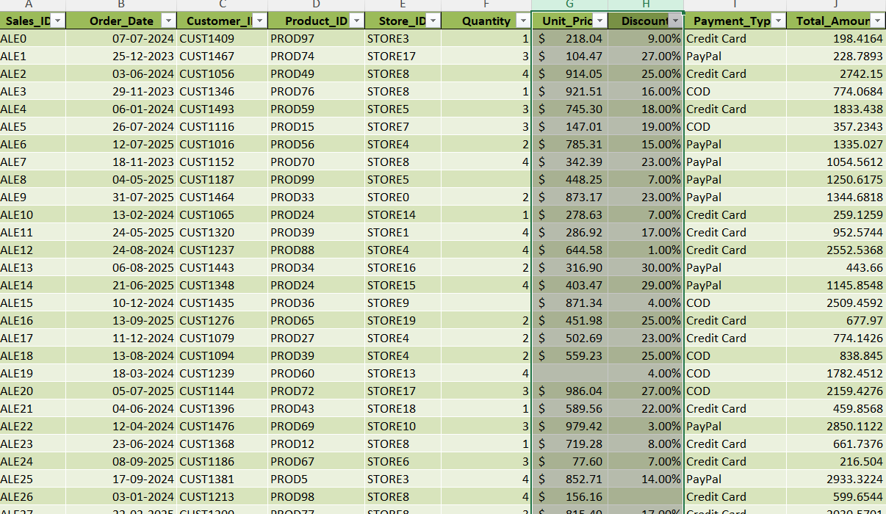

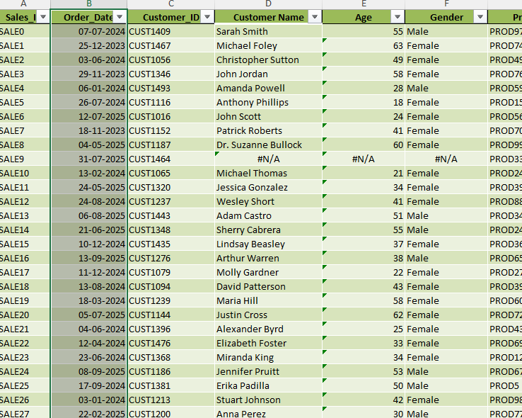

- Then in columns like quantity, unit price, discount, total price, we had some blanks which was identified via key “alt+G” and then replaced with some logical equations.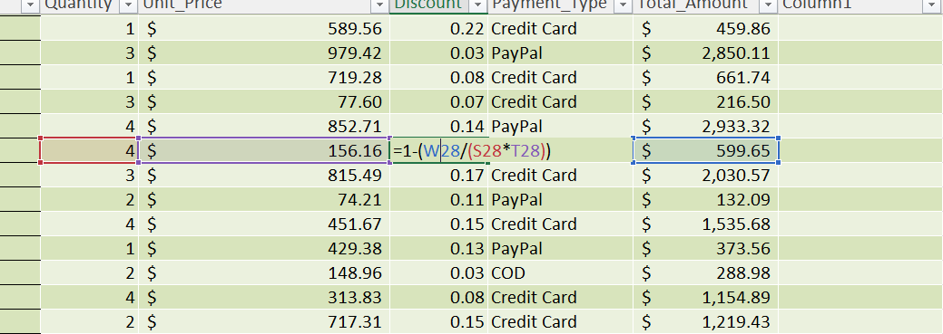
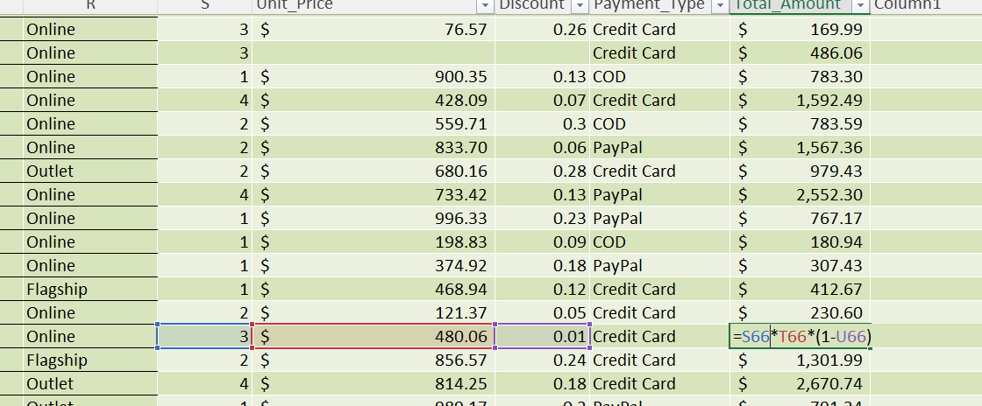
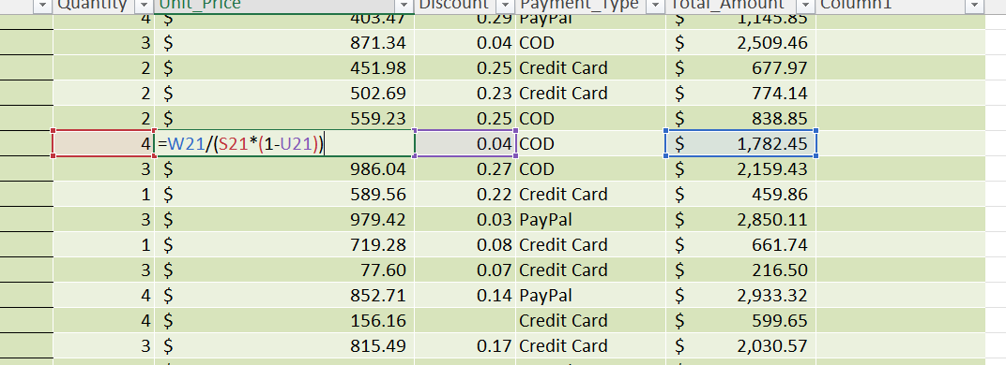

- Use descriptive statistics tool in Data analysis tab in Data tab. We can get all the statistics values in go. Also, we can do conditional formatting with data bars for unit price, discount, and total price columns so that there will be an easy understanding.
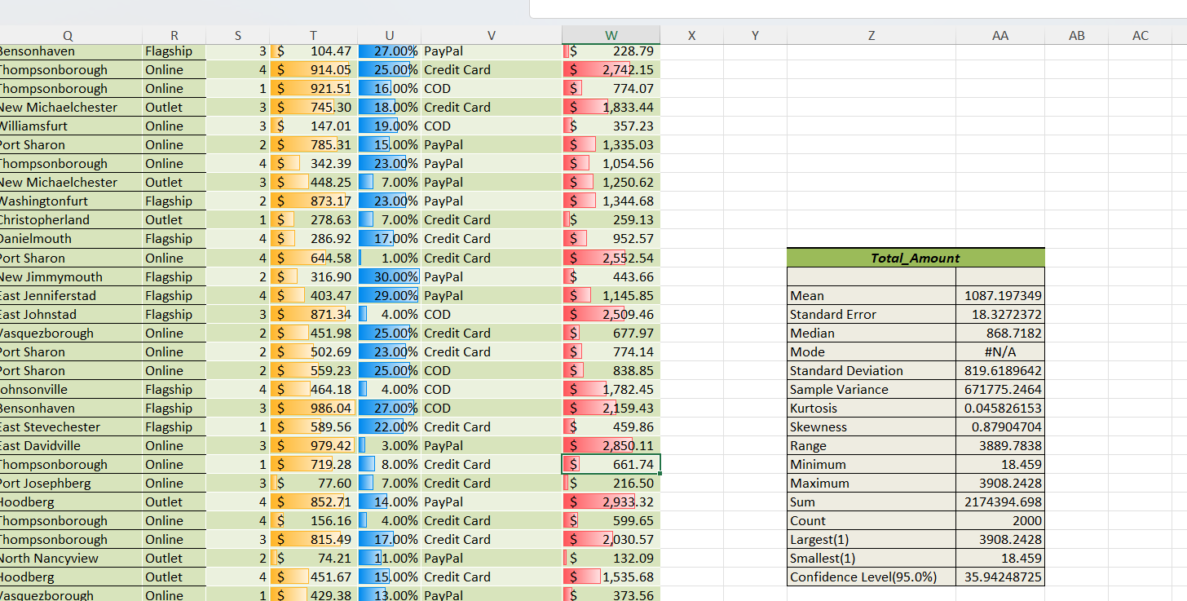

- We can set pivot tables from the combined columns, forming a table.
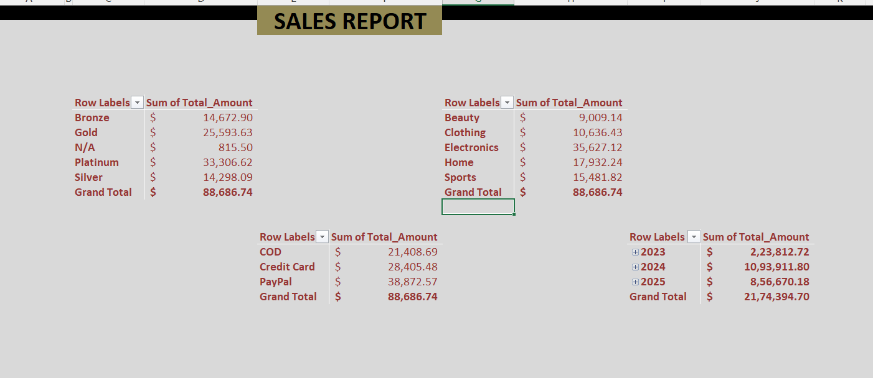

- Finally, we can create dashboards using the pivot tables which we created and also add slicers and timeline to the representation.
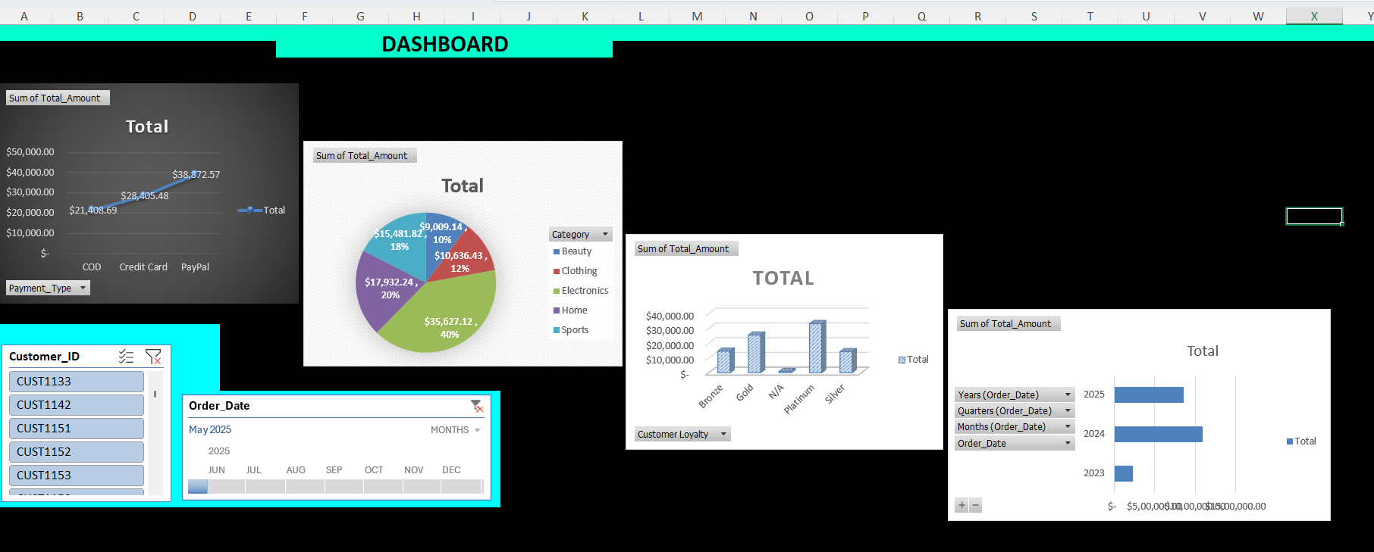

Key Findings and decisions
Data analysis using excel was a great learning experience because It helped in understanding excel in detail. One important lesson is that more the complication of the data, the more will be the chance to learn excel applications. As you all know, “Repetition is the mother of mastery”.

Also, I have learned that many tools have alternate choices, so it is not always necessary to use all of them but don’t forget to learn them all because, it is always best to know Hardest way first.

One more important thing is the use of AI for assistance. It is always good to reach out AI for guidance but don’t let AI make decisions. Use your logical reasoning the most followed by little bit assistance from AI only if required.

THANK YOU

